Testing Issues
16 October 2025

User registration, I received the registration email, I clicked ‘here’ to activate the account
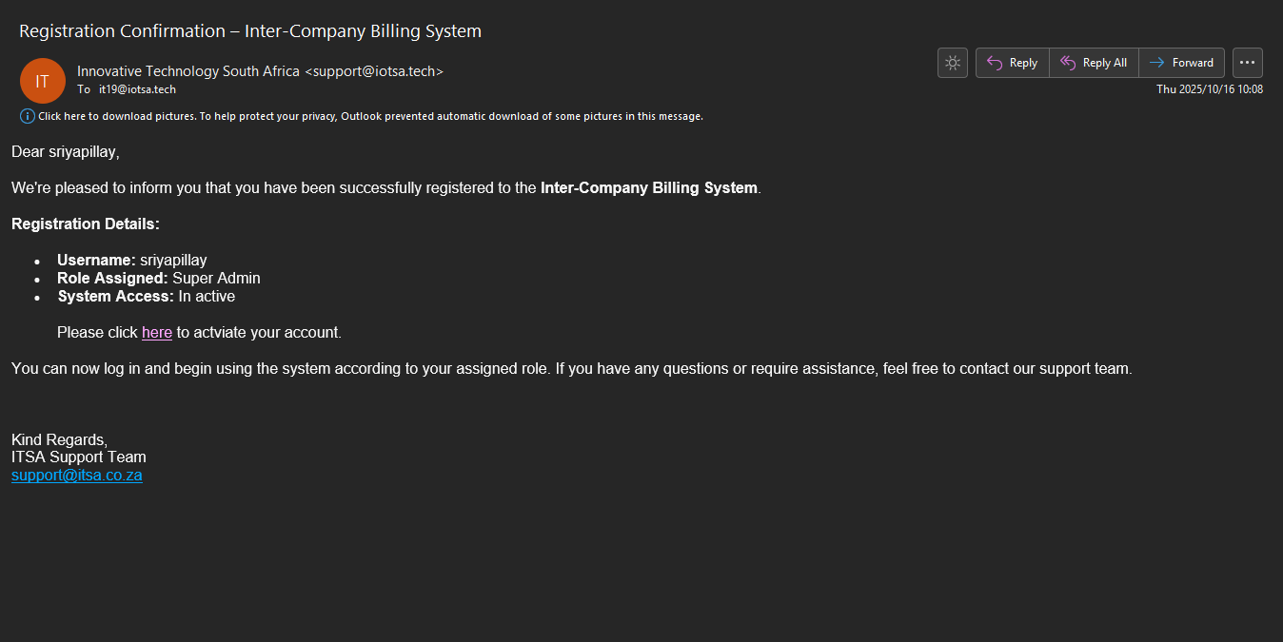
And it redirected me to the login for the system, when I enter the login details, it does not allow me to. And there is no where to ‘activate’
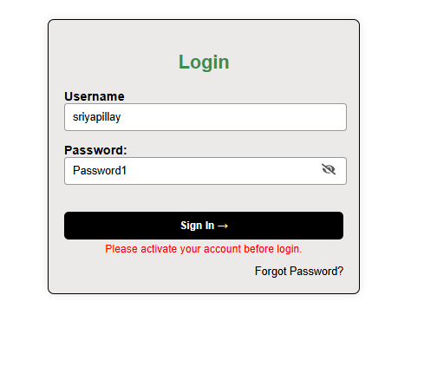
Once the user clicks ‘here’ they should get redirected to a screen that says, you have successfully activated your account and verified your email. Then allow them to login to the system.

Quotation:
After generating a quotation, it gets sent to the receiving entity (customer), however when I click on the link where it says ‘here’, I cannot view the quotation
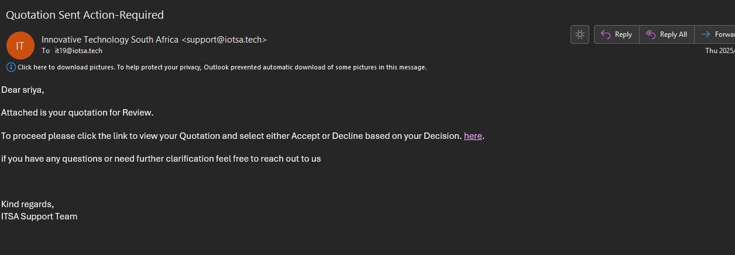
It redirects me back to the login screen for the site
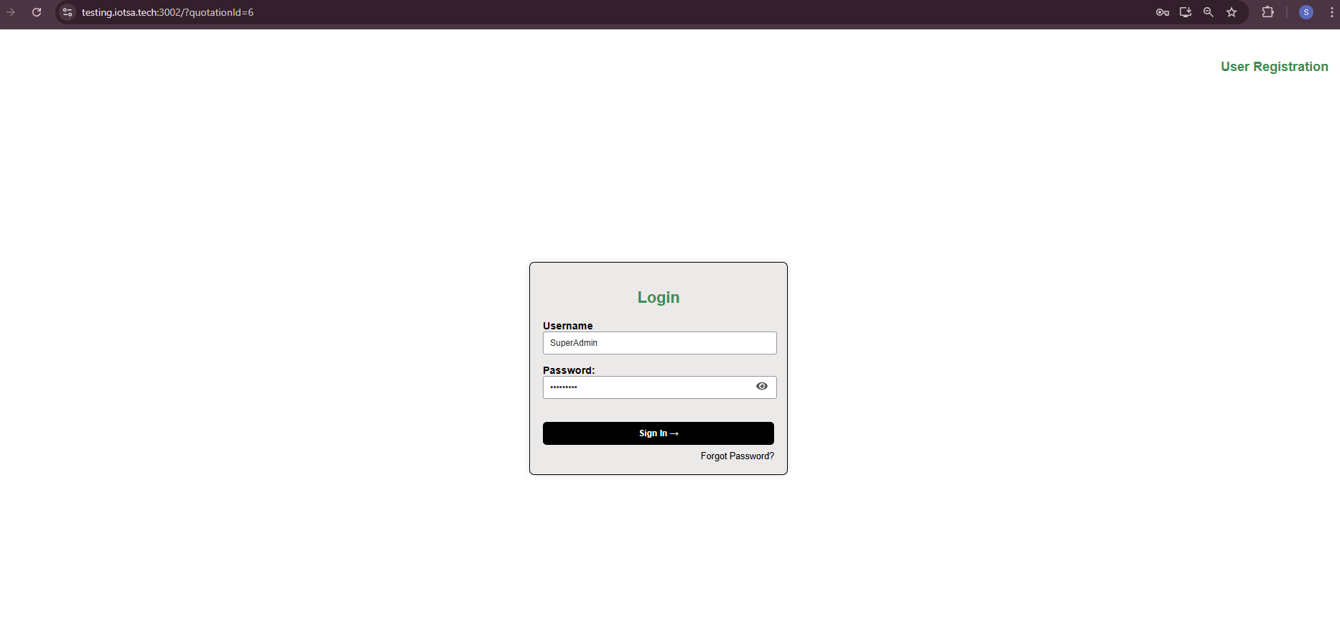
Under quotation when I click view
Information is missing on the quotation
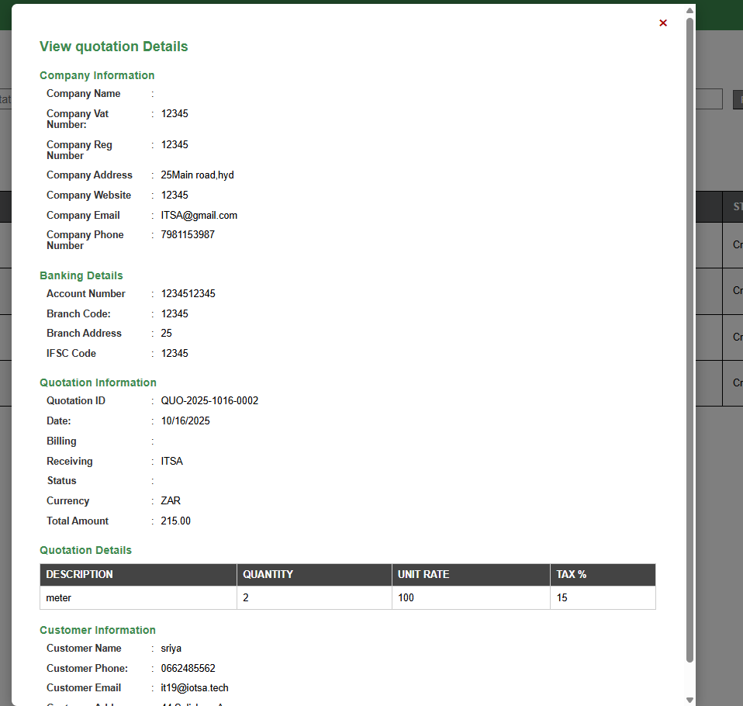

Reports:
After I click view
On the quotation why does it say invalid date- it should be the date it was sent
